Tyger Valley Pet Shelter

# Module: Database Design Concepts

# Project Number: 2

# Student name: Liyema Kota

# Student Number: pt2022j1b7z7

# Date: 17/10/2022

# Introduction

The following project is a database design for Tyger Valley Pet shelter (TVPS). TVPS receives food donations from different food manufacturers and each food manufacturer supplies a specific type of food which is given to a specific pet type, all of which are grouped into different animal categories. The following database design will then keep track of each manufacturer, food type, animal type and pet type.

# Normalization

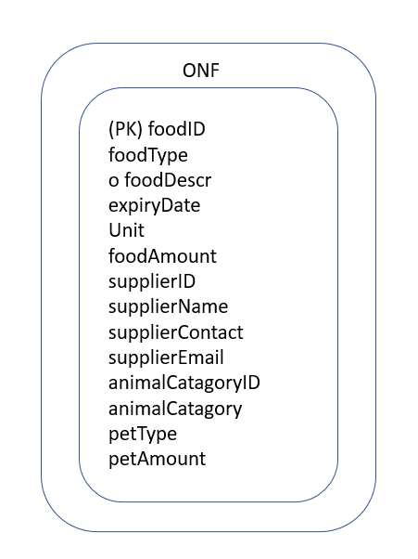

3NF DIAGRAM

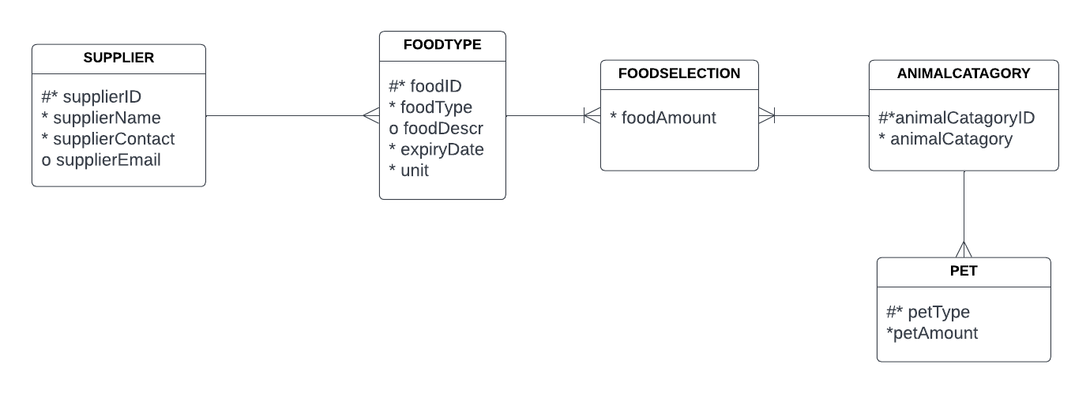

# Mapping from ER diagram

|  |  |  |  |  |  |
| --- | --- | --- | --- | --- | --- |
| FOODTYPE | | | | | |
| Column name | foodID | foodType | foodDescr | expiryDate | unit |
| Key type | PK |  |  |  |  |
| Nulls | NN | NN |  | NN | NN |
| Sample data | Veg125 | vegetable | For mammals or birds | 23/10/2022 | kg |
|  | cow237 | meat | For mammals | 1/11/2022 | kg |

|  |  |  |  |  |
| --- | --- | --- | --- | --- |
| SUPPLIER | | | | |
| Column name | supplierID | supplierName | supplierContact | supplierEmail |
| Key type | PK |  |  |  |
| Nulls | NN | NN | NN |  |
| Sample Data | E256G | SA Veg | (27) 65 445 2015 | saveg@saveg.com |
|  | D284F | Johns Farms | (27) 41 251 5555 | john@gmail.com |

|  |  |  |
| --- | --- | --- |
| ANIMALCATAGORY | | |
| Column name | animalCatagoryID | animalCatagory |
| Key type | PK |  |
| Nulls | NN | NN |
| Sample Data | mam256 | Mammals |
|  | Brd600 | Birds |

|  |  |  |
| --- | --- | --- |
| PET | | |
| Column name | petType | petAmount |
| Key type | PK |  |
| Nulls | NN | NN |
| Sample Data | Dog | 15 |
|  | Birds | 60 |

|  |  |  |  |
| --- | --- | --- | --- |
| FOODSELECTION | | | |
| Column name | foodAmount | animalCatagoryID | foodID |
| Key type |  | PK, FK1 | PK, FK2 |
| Nulls | NN | NN | NN |
| Sample Data | 25 | mam256 | veg125 |
|  | 37 | brd600 | sed205 |